Consider a square classroom which has N\*N number of seats. N is a number that has to be taken from the user.

The professor marks each cell of this tabular data (N\*N cells of same size) as “A” or “P” depending on whether the student who sits on that seat is present today or absent. At the end of the attendance, the table may look something like below

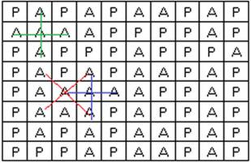

Calculate the number of “+” and “X” signs which are formed by absent or “A” marked cells. The size of the “+” or “X” will be exactly 5 cells so you can ignore any longer/shorter versions. Sample has been highlighted above.

* Ask the user for the dimension N
* Fill the N\*N array with random values of “A” and “P”
* Calculate the number of “+” and “X” as can be observed
* Display exactly which cells were invloded in making each “+” and “X”

*In the example above, N=10, topleft cell is cell 1 and bottom-right cell is cell 100*

*The green + symbol is made up of cell numbers 2, 11, 12, 13, 22*